Technique Training
In this stage, we introduce variations of inquiry-based learning, which help you to create more meaningful relationships and networks.
Overview and recommendations
Key dimensions | Deep processing, self-regulation, self-management
Recommended pace | Most learners see best results with 10 hours of theory across 4 weeks.
Recommended practice | Most learners see best results with 2 to 4 weeks of practice while learning theory.
Progression tips | The most conceptually dense lesson is "Inquiry-based learning", where you will learn an upgraded encoding and note-taking technique. Try to get to this lesson within the first week to have ample time to practice. Most learners need to spend more time on this technique than on previous techniques learned so far.
How this stage helps you
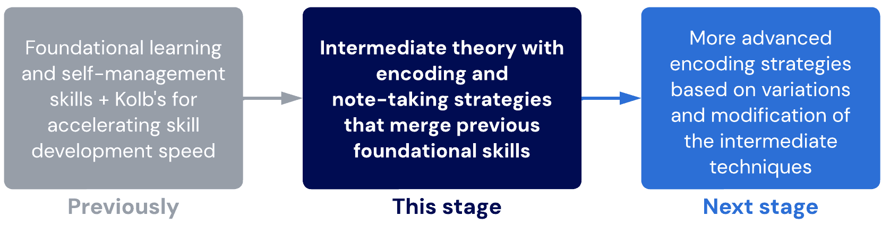
Lessons
- Cave theory
Why do humans learn the way we do? By exploring what the brain adapted to be good at, we can start hacking our memory and efficiency.
sublessons
- Forgetting
The key to unlocking truly efficient learning is to reduce knowledge decay. In this lesson, we discuss the implications of forgetting information at different times and how this affects every other part of our learning system.
- Memory
We explore the nature of memory and how we can cut our rate of knowledge decay.
- Survive and thrive
Let's learn the criteria for increasing relevance using the survive-and-thrive filter.
- Inquiry-based learning
Questions help direct our brain to think in certain ways. We explore the power of questions through inquiry-based learning.
- Order control
We're ready to learn order control, another core principle of learning that applies to every learning session you'll ever have.
sublessons
- Unlearning
The faster you can unlearn old habits, the sooner you can learn new ones. Learn to engage in unlearning effectively.
- Scheduling
Take the next step in your time management skill development.
Sublessons
- Loss aversion
Why do people stay on a sinking ship? Learn about how loss aversion can impede your growth.
- Final checkpoint – Technique Training
Assess your skill level and see if you're ready to move on to the next stage.

- Cave theory
Cave brain in a modern world
Our brain is the same as it has been since caveman times, but modern learning is very different. The way we tend to learn now is deeply influenced by the formal education system and the industrial revolution.
As a result, the way many people learn is disconnected from how our brains want to and prefer learning. Our cave theory tells us we need to learn how the brain likes to learn, which makes learning more effective, engaging, and even enjoyable!
Techniques overview
The following are new techniques or systems we will introduce in Technique Training.

New Techniques | Rationale
Traffic light system | A beginner’s introduction to self-facilitated inquiry-based learning. The basic skills from this technique will be built on in the Ascent stages.
Scheduling basics | Some more basic scheduling tips to help you stay on track and manage your time.

Don't stop!
Remember to continue the other parts of your system we've already learned.
Just because we don't teach you any new techniques about time management or retrieval (for example) in one stage doesn't mean you should stop using what you already learned.

Sublesson: Cave theory example
Think of a hobby, series, sport or instrument. How would you teach a complete beginner about this?
You are probably imagining methods of teaching and learning that are drastically different from how you might study and learn more "formal" or "intensive" topics. Some of the topics we know best have been learned without ever using traditional "studying methods". Likely, your brain learned in a way that felt natural and efficient (and probably enjoyable).
Many believe that studying within curriculums and courses cannot be like this. However, information is just information. They would be surprised to find out that the learning methods we will teach you allow you to use your brain in that authentic, efficient way that it's capable of.

- Forgetting
Retention is the ability to remember something without forgetting it and retrieve it whenever necessary. If our retention is poor, most of our time is spent relearning information we’ve forgotten. If we improve our retention, the time required to learn a topic drastically decreases.
Measuring learning efficiency
A common trap people fall into is prematurely thinking that learning techniques don’t work for them because they are measuring retention in inaccurate ways
See our article here for how you can measure your real learning efficiency.
Related videos
You may be interested in this video which mentions the idea of measuring learning using useless metrics: https://www.youtube.com/watch?v=P4_j2VggToM

- Memory
What is a "good memory"?
Information (or memory) is stored in your brain as a network. Your brain determines whether information is worth retaining (remember Cave theory) based on how connected this information is to other information.
- If it's part of a bigger network, it judges it to be probably more important and, therefore, worth keeping.
- If information is isolated and not very connected, it is probably less relevant. Your efficient brain will cleanly prune it!
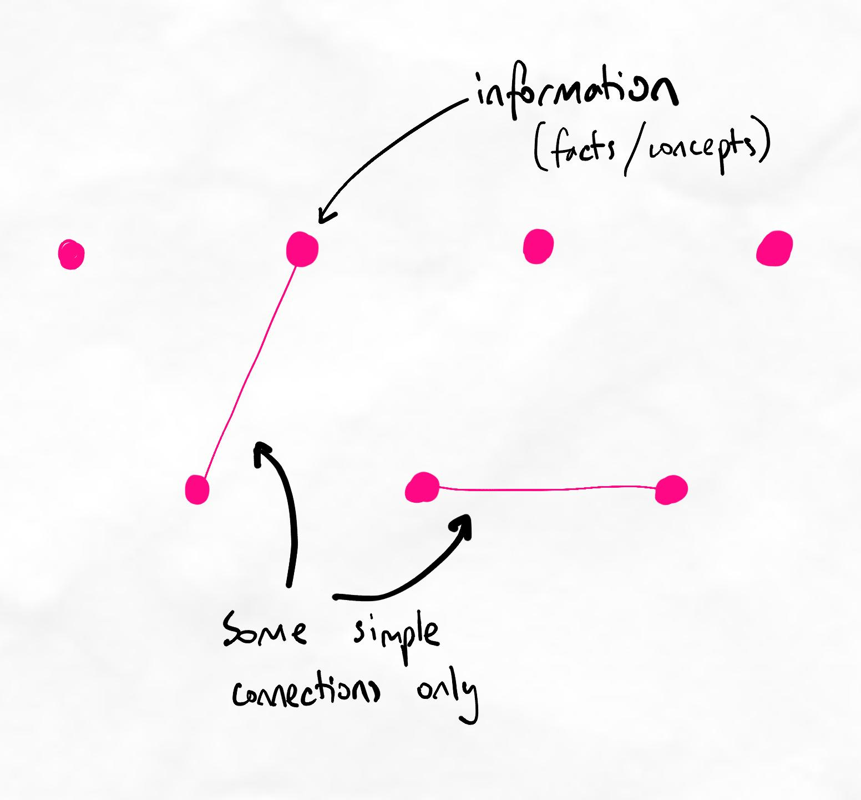Simple information that is isolated (or only some simple connections) is forgotten easily.
Reference regarding hypercorrection
The hypercorrection effect in younger and older adults

- Survive and thrive
Survive-and-Thrive: It's all about the network
Information is given value, meaning, and strength of memory based on it's relationship to other pieces of information. For example, if a fact is memorised by itself - it is not related to anything else. If a concept is understood, we might think we will remember it, but if the concept is not related to any other concepts, we will still forget it.
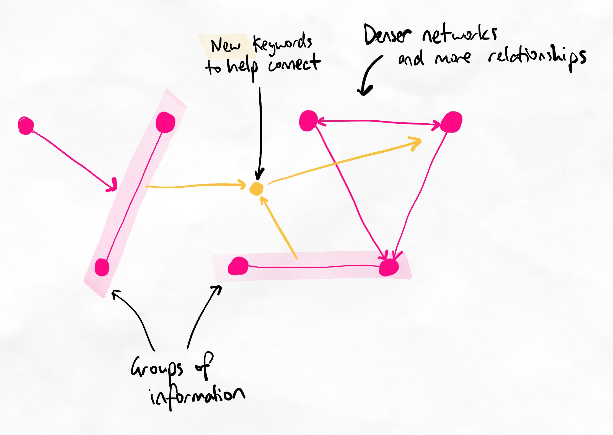Groups and relationships create structure and organisation. The resulting network produces better memory.

Examples of methods that improve memory and depth
All of the methods below are examples of techniques that help form networks of knowledge, which improve memory and depth:
- Creating analogies that are accurate and comprehensive
- Relating new information to knowledge you already have
- Simplifying new terminology by giving them simpler names you find more intuitive
- Applying information and solving a problem immediately
- Comparing new information with other new information to see how they are related to each other
- Grouping new information into chunks based on shared similarities
- Drawing arrows between chunks based on how the chunks affect each other
- Positioning chunks on your notes in different places depending on the other concepts they might need to be connected to

Types of relationships
Think about the cognitive processes involved in each of the methods above.
Notice how methods 1, 2, and 3 create connections between new information and existing knowledge (we call these analogous relationships), whereas methods 5 to 7 create connections between new information (we call these in-context relationships). Method 4 could be both analogous or in-context, depending on the type of problem we are trying to solve.
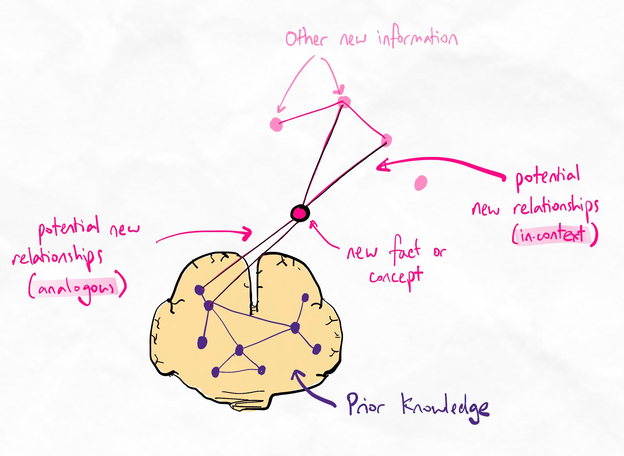Relationships built with other new information (in-context) vs. with existing knowledge (analogous)
Therefore, we can say that there are two types of networks we can form with new information: analogous and in-context. When we learn, we should always try to make both types of connections, if possible.
There are also ways to help prime our brains to create relationships (both analogous and in-context). For example, doing some problem-solving or practice questions before learning a topic can help prime us about potential relationships. Correct prestudy techniques that build big-picture understanding also give us more points of relevance to not only build analogous relationships but also make it easier to perceive and hypothesise in-context relationships.

Examples of analogous relationships
- Jill learns about the physiology of muscle contraction. She tries to make sense of it by creating an analogy of a person climbing up a ladder.
- Geoffrey learns about how a dam generates electricity using water currents. He makes sense of this by relating the mechanisms to his understanding of how wind turbines work that he learned in the previous semester.
- Sarah is learning about the principles of economics. She forms an analogy by equating supply and demand to a seesaw, where the equilibrium point is the balance achieved when both sides are equally weighted.
- Robert is exploring the principles of genetics in his biology class. He draws upon his prior knowledge of Mendelian inheritance from a previous semester to understand how genes are passed from one generation to the next in complex genetic traits.
- Emily is learning about international trade and globalization in her economics course. She connects this to her previous studies in history, understanding that trade routes and the exchange of goods have shaped the course of civilizations throughout history.
- Samuel is diving into the study of 20th-century literature. He relates the themes and social contexts of the literature he is currently reading to his earlier coursework in sociology, recognizing how societal changes influenced the literary works of that era.
- Ethan is exploring the concept of chemical reactions and catalysts. He relates this to a cooking analogy, likening reactants to ingredients in a recipe and catalysts to a chef's secret ingredient that speeds up the cooking process.
- Alex is studying the structure of an atom in chemistry. To simplify it, he creates an analogy where the nucleus is the "core" of an atom, and electrons are like planets orbiting around it, similar to our solar system.
Examples of in-context relationships
- Sarah is studying environmental science and has just learned about the water cycle. She immediately applies this knowledge to analyze the recent weather patterns in her region, forming an in-context relationship between the theory of the water cycle and its real-world application.
- In a history course, Michael is exploring the causes and consequences of World War I. He compares and contrasts these with the events and outcomes of World War II, identifying in-context relationships between the two major historical events.
- In a biology lecture, Finn is studying cell division and the cell cycle. He makes theoretical connections to the concept of mitosis and meiosis, understanding how these processes govern cell replication and genetic diversity.
- In an economics seminar, Joanna is delving into supply and demand dynamics. She observes the theoretical link between supply and demand curves and the concept of market equilibrium, where the quantity demanded equals the quantity supplied.
- In a music theory class, Jihee is learning about chord progressions and harmonic structures. She discerns the theoretical connection between diatonic chords and the concept of tonal harmony, understanding how certain chords naturally complement each other within a musical key.
- In a chemistry lab, Emily is experimenting with chemical reactions and observing how different factors affect reaction rates. She draws connections between her observations and the chemical principles she learned in lectures, creating in-context relationships between theory and practical experimentation.
- John is taking a finance course and has just studied the concept of compound interest. He immediately applies this knowledge when evaluating different investment options, forming in-context relationships between the financial theory he's learned and its practical implications for personal finance decisions.

Why does the difference in types of relationships matter?
Although we separate them into analogous vs. in-context in this lesson, many methods can help with both (directly or indirectly). The goal is not to be absolutely certain about which relationships are in-context vs. analogous but rather to remind ourselves to always look for both types of connections when possible. We may struggle to relate information to prior knowledge but find it easier to make in-context relationships, or vice-versa.
If you cannot make any relationships, it likely means what you are learning is too detailed for your current level of knowledge. Instead, we need to build a stronger foundation of surface-level knowledge with prestudy. We will introduce more techniques related to this concept in the later stages.
Memory and understanding are symptoms
Our brain adapts to solve problems and learns things along the way. Good memory and depth of understanding are symptoms of your brain creating good knowledge structures. It does not come from simply intending to remember or understand something!
In the classical view of Bloom's taxonomy, memorising and understanding are considered the bottom levels. We commonly refer to this as lower-order learning. However, Bloom's has also been criticised for representing knowledge and learning in a hierarchy. We know now that this is not entirely accurate.
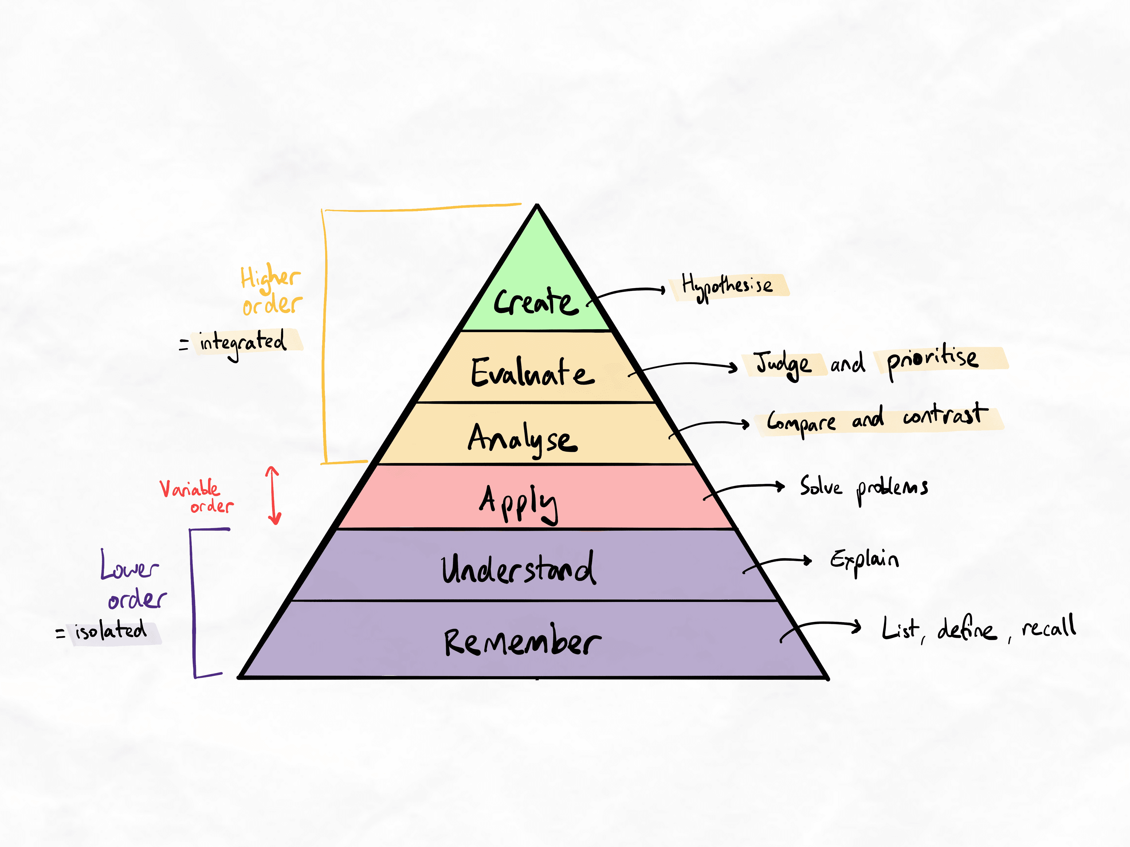
The classical view on Bloom's revised taxonomy (2001)
In reality, memory and understanding occur when we engage in effective learning strategies. It is not a linear order we must follow, starting from the bottom and working our way up to the top. In authentic learning, we constantly go back and forth between levels. Dr Justin Sung created his own framework to explain this.
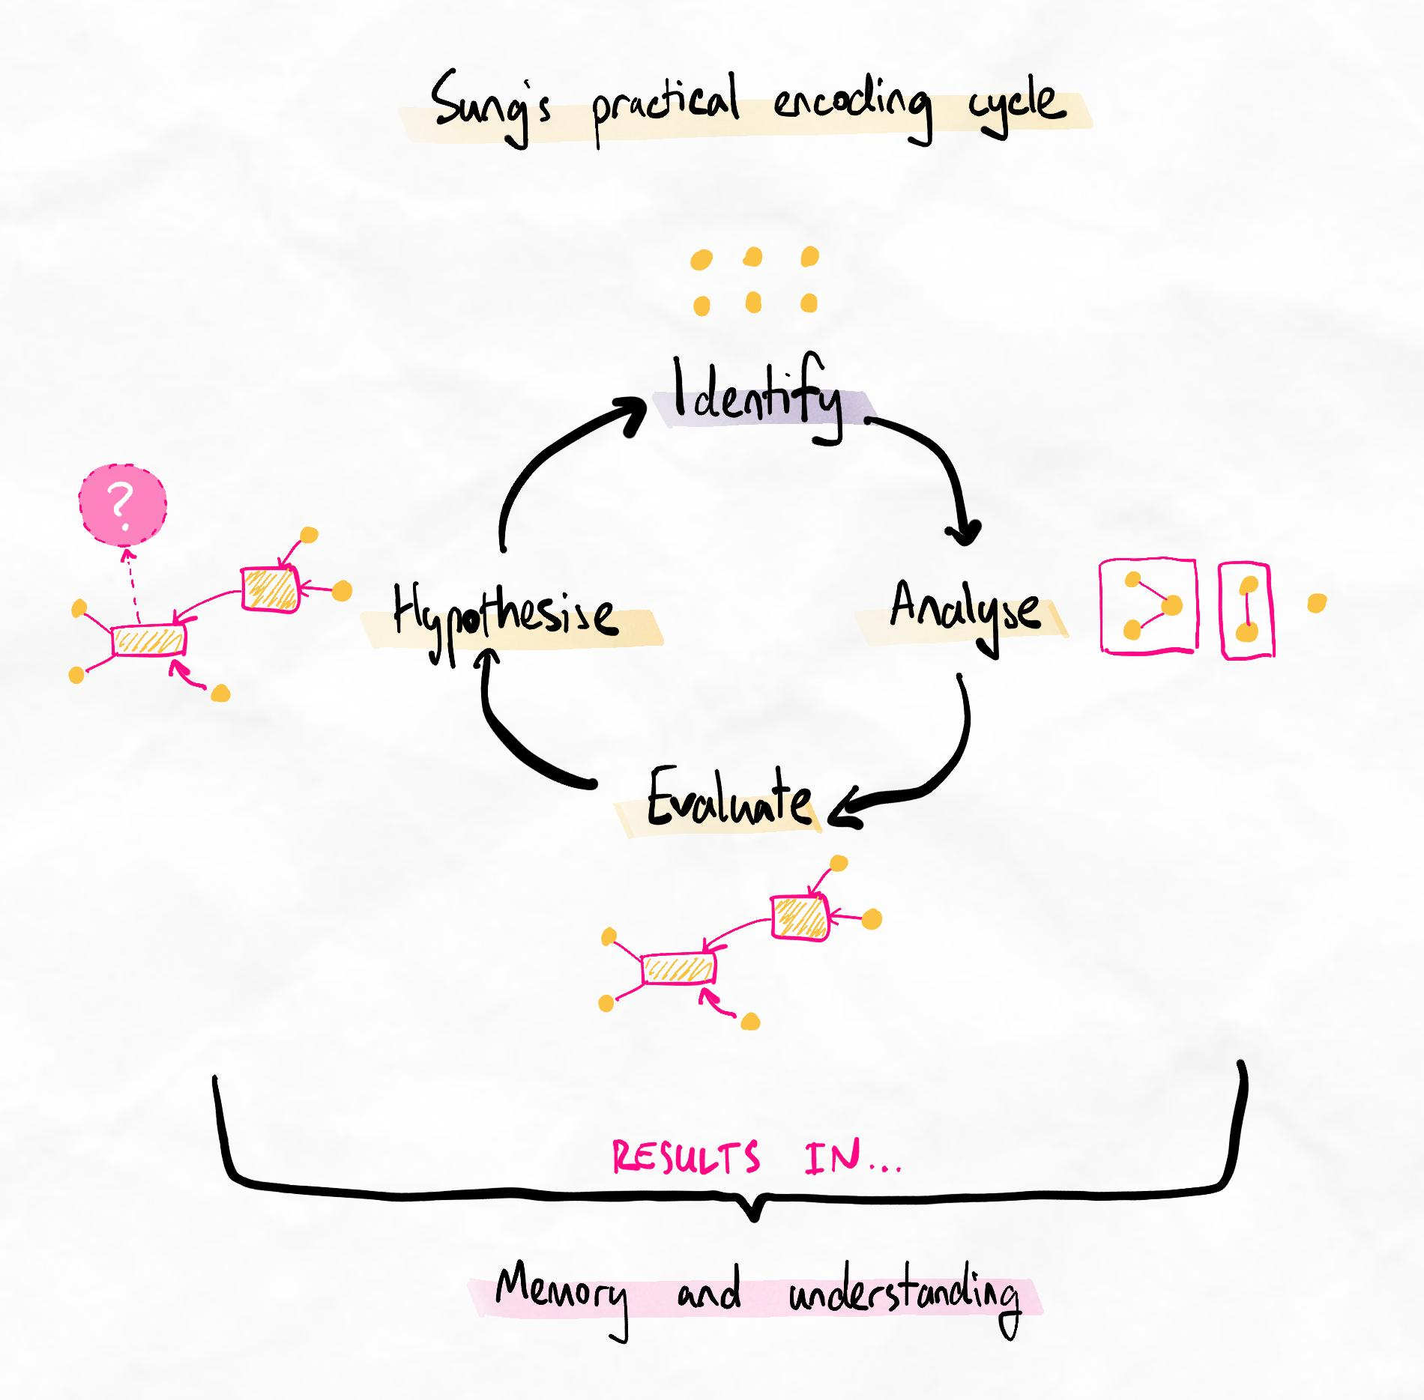Sung's practical encoding cycle (2023)
In the lessons to come, you will learn to engage in this encoding cycle, operating exclusively in the higher orders of learning, to create strong memory and understanding.
Memory and depth is a symptom
Our brain adapts to solve problems and learns things along the way. Good memory and depth of understanding are symptoms of your brain creating good knowledge structures. It does not come from simply intending to remember or understand something!
Related additional reading (optional)
System 1 vs. system 2 thinking
The brain recognises if information is worth processing or not. It always looks for an energy-efficient shortcut. This split in the way our brain thinks has been noted in lots of research, including Thinking Fast and Slow by Daniel Kahneman, who won the Nobel Prize based on his work. He identified two systems of thinking, one fast and reactive (based on pattern recognition) and one slow and deliberate.
The hot-cold empathy gap
Differences in our brain's processing ability can also be seen in hot vs. cold decision-making. This phenomenon is where we make different decisions when under pressure or stimulated (hot) than when we are calm and calculating (cold).
For example, while you are “cold”, you decide to study for 2 hours after school. However, after school, you are tempted to watch YouTube or go out with your friends, and you make a different decision in the heat of the moment.
This difference in how we think causes so many problems that there is even something called the hot-cold empathy gap, which talks about the problems that arise from the bad decisions we make when we are hot.
Quiz: Methods of memory quiz
How effective are these methods in supporting high-quality knowledge and memory? This quiz will help you examine different methods and understand if they are likely to be effective or not.

Question 1
Regarding what you have learned about the nature of memory, which of the following methods would produce the worst effect on retention?
Creating an analogy for a new concept.
Reading and re-writing information multiple times.
Creating and reviewing flashcards on simple facts and concepts.
Mapping how concepts relate to other concepts.
Creating simplified groups of information based on their similarities.
Ans: Reading and re-writing information multiple times.
Learning notes
Simple reading and re-writing does not create any relationships or build networks. This method can be considered a complete waste of time.

Question 2
Regarding what you have learned about the nature of memory, which of the following methods do not build networks of knowledge? Select all that apply.
Creating an analogy for a new concept.
Reading and re-writing information multiple times.
Creating and reviewing flashcards on simple facts and concepts.
Mapping how concepts relate to other concepts.
Creating simplified groups of information based on their similarities.
Ans: Reading and re-writing information multiple times.
Creating and reviewing flashcards on simple facts and concepts.

Learning notes
Reading and re-writing, as well as isolated fact recall with flashcards are both examples of common methods that do not create knowledge networks. This results in lower overall retention and increased workload to try and reach the desired level of performance.
However, flashcards still have a positive effect on retention through spaced retrieval. For some types of information, this can be a valid method to add to a toolkit. It is unlikely to be sufficient if used as the primary method of learning.

Question 3
Regarding what you have learned about the nature of memory, which of the following methods help to improve retention but not necessarily the ability to use information for complex applications? Select the most correct answer.
Creating an analogy for a new concept.
Reading and re-writing information multiple times.
Creating and reviewing flashcards on simple facts and concepts.
Mapping how concepts relate to other concepts.
Creating simplified groups of information based on their similarities.
Ans: Creating and reviewing flashcards on simple facts and concepts.

Learning notes
Flashcards can improve memory through spaced retrieval. However, they do not build networks if used on isolated facts and concepts.
Creating an analogy for a single new concept arguably has minimal impact on building knowledge that is helpful for complex applications. Creating analogies for multiple concepts and how they relate to each other would be much more helpful. However, flashcards are still the most correct answer in that they generate even less networks than analogies of single concepts.

5.Inquiry-based learning

The power of questions
When we learn by creating problems and then answering them, it changes what information we consume and how we think about things. This process of seeking an answer and being curious, followed by satiating that curiosity, is called inquiry-based learning.
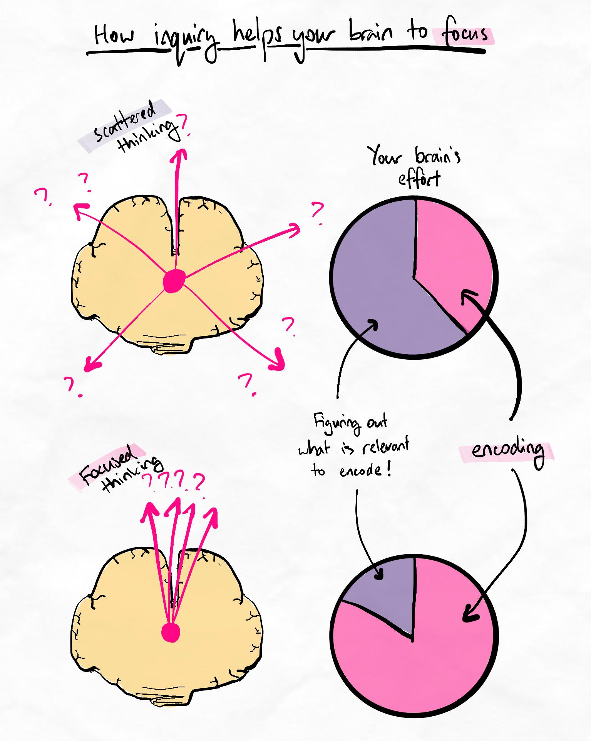Inquiry and questions help your brain focus on what is relevant.
When we learn by solving problems, it also gives us more information to ask even more questions. This ongoing cycle results in a deeper, more applicable understanding and a higher retention rate.
People often struggle to apply the knowledge they’ve learned. The real issue is that people usually do not try to apply information immediately after they've learned it.
That’s like running down a road because someone told you to, only to realise an hour later that you don’t know where you’re going or why you’re running!
Key principle
Studying only produces learning when the information you consume has a purpose. Problems can help create purpose.
Conventional learning is unfocused and causes you to learn too much information at once, making it harder to process. This causes you to forget the information quickly, so you will waste a lot of time going back and relearning it. In addition, your brain doesn’t like the unstructured nature of conventional learning, so you will feel the information is tedious and unenjoyable.
It’s like throwing a bunch of items into a room, then realising you don’t know where anything is, so taking it all out and organising it again. The better approach would have been to organise it first!
🚦 The traffic light system

To start implementing inquiry-based learning, you can train your brain using the traffic light system (TLS). TLS is divided into red light vs. green light phases of learning.
Red light forces us to think of questions and directs our focus. It helps break bad habits of passive learning or just reading and consuming information without a clear big-picture purpose.
Green light is when we satiate our curiosity by answering those questions. This is when we read, listen, and search through content to find relationships, write our notes, and think about how everything is connected.
🔴 Red light
When you first start studying, create a list of keywords and concepts. It doesn't have to be comprehensive but try to cover the main ideas of the topic.
Questions to ask during red light
Once you have a list of keywords, ask yourself the following questions...
- Which keywords feel easier or more relevant to me immediately? (Start with these keywords)
- What am I curious about?
- Why do I need to know this?
- What problems does it help me solve or how can I apply this?
As you ask yourself these questions, you may think of other questions to ask, especially relating to what you are curious about. Make a note of these questions for the green light step coming next.
By the end of red light, you should have a list of questions to answer.
🟢 Green light
Go and answer those questions to learn the topic in an organic way. Don’t read everything and try to memorise all the information. Instead, focus on naturally answering the questions you have asked.
Tips for green light
While answering your questions, follow these principles...
- Think of multiple answers for each question. The point is not to find one perfect answer but to use the question as a springboard to find multiple relationships.
- As you explore each keyword, you will find many relationships between keywords. Try to express these in your notes. It will be messy at first!
- After every 2 or 3 keywords, look at your growing map and try to simplify it and make it cleaner. Make judgments on what is important and worth keeping.
- Continually revise your overall structure. Your map won't be "concrete" until much later. Everything you map now is just to help you think and organise your thoughts.
Green light finishes once you have answered all your questions from red light. Go back to red light and continue this cycle until you feel like you have learned most of the topic.
Some information may still be so detailed and specific that you struggle to answer the related questions. These can go on your flashcards or other lower-order rote-memorisation method for now.
Keep your note-taking non-linear!
During TLS, you'll find that you discover lots of new relationships! Make sure to use good non-linear note-taking to help your brain think about and explore all these different relationships. Trying to figure it all out in your head will be overload!
If you're still using the collecting and processing technique, now is a good time to start moving towards fully non-linear "mindmap" style note-taking.
Common questions
Which keywords should I start with?
You can start from any keyword that you feel is an important idea. However, with correct inquiry, you should be able to start from any keyword and identify which words are truly the most important.
The goal of inquiry is to compare and contrast ideas and see how concepts influence and are related. We then group words based on this information. Remember not to let your groups be dictated by how it was presented to you or your preconceived (potentially suboptimal) ideas about how the information should be organised.
To be an effective learner, we must arrive at our own critically examined conclusions about how to organise the information.
Table of contents:Doing TLS correctly
Tls Clarification
Doing TLS correctly
In the beginning, don’t try to make perfect questions. It is normal and perfectly fine to struggle with asking questions, but you must keep asking them if you want to improve.
The objectives are to:
- Think of questions that create curiosity and potential relationships
- Train our brain to become more curious
- Train our brain to learn based on our line of curiosity
- Become familiar with how asking questions affects the way we process new information
The video below clarifies some of the nuances around performing TLS correctly. You may wish to come back to review this video after having your first attempt so it is more relevant.
Example of TLS for maths
It can be difficult to learn a topic like maths (or even chemistry) in a way you are not used to. Here is a worksheet created by one of our students and reviewed and approved by our team that you can use to solve some of the mistakes you might make while working through maths problems.
Although this worksheet is for maths, you can use the same approach for mistakes made in any subject!
This worksheet will be given to you again in Ascent 2 as a reminder.
Problem-Solving Worksheet – Maths (Download)
Controversy and problems with inquiry-based learning (optional reading)
Problems
Researchers have recently contested the effectiveness and validity of inquiry-based learning. Their concerns are valid. Inquiry-based learning suffers from the following:
- Lack of agreed definitions on what constitutes inquiry-based learning
- No clear guidelines on how it can be implemented
- Significant dependency on the facilitator
- Significant variation in effectiveness observed in empirical research
- Questionable underlying theory
- Questionable underlying science
Furthermore, almost all of the research on inquiry-based learning is aimed at educators and curriculum makers rather than individual learners. It is currently not considered a method that individuals apply for themselves in self-regulated learning practice.
Learning researchers in the cognitivist school of thought (compared to traditionally constructivist perspectives on learning) argue that there is no validity to inquiry-based learning due to the above problems.
Our perspective
Inquiry-based learning in the current research space is indeed highly limited. In some cases, the way it is implemented is either useless or harmful. The direction of research in the mainstream research space is also not highly promising. Many researchers seem to be ignoring the criticisms and justifying the validity based on the same flawed arguments.
However, the underlying theory of inquiry-based learning has significant overlap with currently more empirically supported cognitivist theories within cognitive load theory. Our approach is to extract the useful aspects of inquiry-based learning and frame it from a self-regulated learner's perspective. Unlike any other approach to inquiry-based learning that we have seen, we teach it from a cognitivist perspective.
As a result, we have seen this approach being able to produce consistent, theoretically aligned effects in learners. The version of inquiry-based learning we teach is substantially modified and, therefore, technically not considered inquiry-based learning within mainstream research.
Related references
Constantinou, C. P., Tsivitanidou, O. E., & Rybska, E. (2018). What Is Inquiry-Based Science Teaching and Learning? In O. E. Tsivitanidou, P. Gray, E. Rybska, L. Louca, & C. P. Constantinou (Eds.), Professional Development for Inquiry-Based Science Teaching and Learning (pp. 1–23). Springer International Publishing. https://doi.org/10.1007/978-3-319-91406-0_1
Edelson, D. C., Gordin, D. N., & Pea, R. D. (1999). Addressing the challenges of inquiry-based learning through technology and curriculum design. Journal of the Learning Sciences, 8(3–4), 391–450.
Kirschner, P. A., Sweller, J., & Clark, R. E. (2006). Why minimal guidance during instruction does not work: An analysis of the failure of constructivist, discovery, problem-based, experiential, and inquiry-based teaching. Educational Psychologist, 41(2), 75–86.
Khalaf, B. K. (2018). Traditional and Inquiry-Based Learning Pedagogy: A Systematic Critical Review. International Journal of Instruction, 11(4), 545–564.
Pedaste, M., Mäeots, M., Leijen, Ä., & Sarapuu, S. (2012). Improving students’ inquiry skills through reflection and self-regulation scaffolds. Technology, Instruction, Cognition and Learning, 9(1–2), 81–95.
Rönnebeck, S., Bernholt, S., & Ropohl, M. (2016). Searching for a common ground – A literature review of empirical research on scientific inquiry activities. Studies in Science Education, 52(2), 161–197. https://doi.org/10.1080/03057267.2016.1206351
Sweller, J. (2021). Why Inquiry-based Approaches Harm Students’ Learning. The Centre For Independent Studies. https://www.cis.org.au/publications/analysis-papers/why-inquiry-based-approaches-harm-students-learning/

Meta-checklist
The table below outlines how using this technique can feel and what these feelings mean at a cognitive level. Refer to this table to improve your metacognition and ensure you understand the purpose of the technique. Connecting your emotional experience with the cognitive processes of learning helps you make fine-tuned adjustments and solve any technique issues more easily.
How it can feel | Cognitive outcomes
Chaotic as you go back and forth between questions and your material. | Engages more higher-order, integrative thinking, which helps to build networks and relationships.
Confusing as you try to answer your questions. | Improves active learning and deep processing, which helps you to achieve knowledge mastery earlier.
Confusing or overwhelming as you try to create a non-linear structure that includes the relationships in a way that makes sense. | Forces prioritisation and evaluation (one of the highest orders of learning). It helps you connect your note-taking with your thought processes.
More curiosity and a feeling of active effort while learning. | Indicates that you’re using more cognitive resources for the learning task. If you’re doing the technique correctly, this translates to more effective learning.
Insecurity and anxiety as you skip some details and learn out of order. | Creates mental schemas and knowledge structures in the way your brain finds most relevant. These feelings indicate that you are correctly ignoring information until the right time (i.e. when it becomes more relevant).
Using meta-checklists
Meta-checklists are metacognitive observations that you can use to check that you are performing techniques correctly. We recommend using these checklists whenever you do Kolb's on this skill or conduct skill audits and rapid learning system assessments.

Recommended tasks
Add tasks to your focus list so you can practice the skills.
Dimensions
Technique Training
Complete your first traffic light system
Following our instructions, complete your first learning session using the TLS. We recommend at least one hour for your first attempt to have sufficient experience with the types of desirable difficulty this technique induces.
Complete this task once you have completed your first attempt at using TLS.
Dimensions
Technique Training
Complete Kolb's on your first TLS attempt
Complete a Kolb's cycle on your first TLS attempt. You can refer to the meta-checklist to help guide your metacognition, self-awareness, and reflection.
Complete this task once you have completed your Kolb's.

6.Order control
Taking control
One of the key differences between inquiry-based learning and conventional learning is the order in which information is gathered.
How we tend to learn conventionally | How we learn with inquiry-based learning
The first thing we are given is the first thing we start to learn. | The first thing we learn is the point we feel most curious about or feel the most relevance to.
The order in which we learn information depends on how the material is structured and presented in resources, classes, and lectures. | The order in which we learn information depends on our thought process and how we are building our personal knowledge network.
If detailed information that feels irrelevant or overloading is presented to us, we spend time and effort to learn it then. | Information that feels relevant is sought so that detailed information that would normally overload us is delayed until we are better able to make sense of it.
Feels overwhelming or irrelevant at times. | Always feels manageable and relevant because we pick a path of relevance.
Because the types of relationships we build depend heavily on our prior knowledge and how we can make sense of information, the "best" order to learn a topic will differ for each person.
Methods such as the Traffic Light System help us to be more deliberate about the order in which we learn new information.
What does the right order mean?
Many learners initially feel uncertain about learning in a different order from how the content is presented to them. Remember, resources are not created directly for your brain and set of knowledge. Experts try to take their knowledge network and present it in a way that they assume will make sense.
It is always the job of the learner to take this information and construct their own knowledge network.
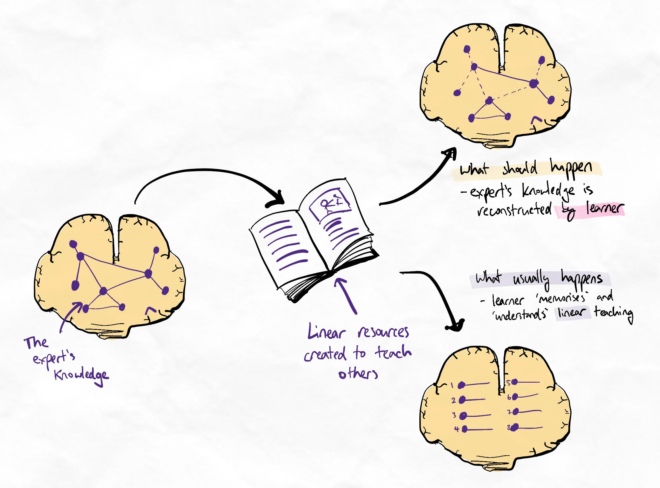Expertise has no "order". It is non-linear. However, many learners prioritise the linear order of teaching.
Sublesson: Order control insecurities
Order control insecurities

Safety in layers
The Swiss cheese model shows that it’s extremely difficult to miss information because you are revisiting and asking questions in several rounds. By comparison, if you use conventional linear learning, it is actually much easier to miss things as our brain is not a photocopy machine and will miss many points.
7. Unlearning
Out with the old
We have helped many people learn to learn more efficiently and gain more time in their lives. However, there are also many who struggle to improve due to issues with unlearning.
The ego of unlearning
Unlearning is the ability to replace old habits, skills, ideas and practices with alternatives that are more effective. This requires us to detach from our ego and acknowledge that our practices are sometimes wrong.
Unlearning is crucial for success
Studies have shown that successful people have a strong ability to unlearn.
To adopt a new system or habit, you must take your old habits and unlearn them. If you retain the bad habits from your old learning system, this jeopardises the effectiveness of your new system. Be open to adopting new practices and exercise your unlearning skills.
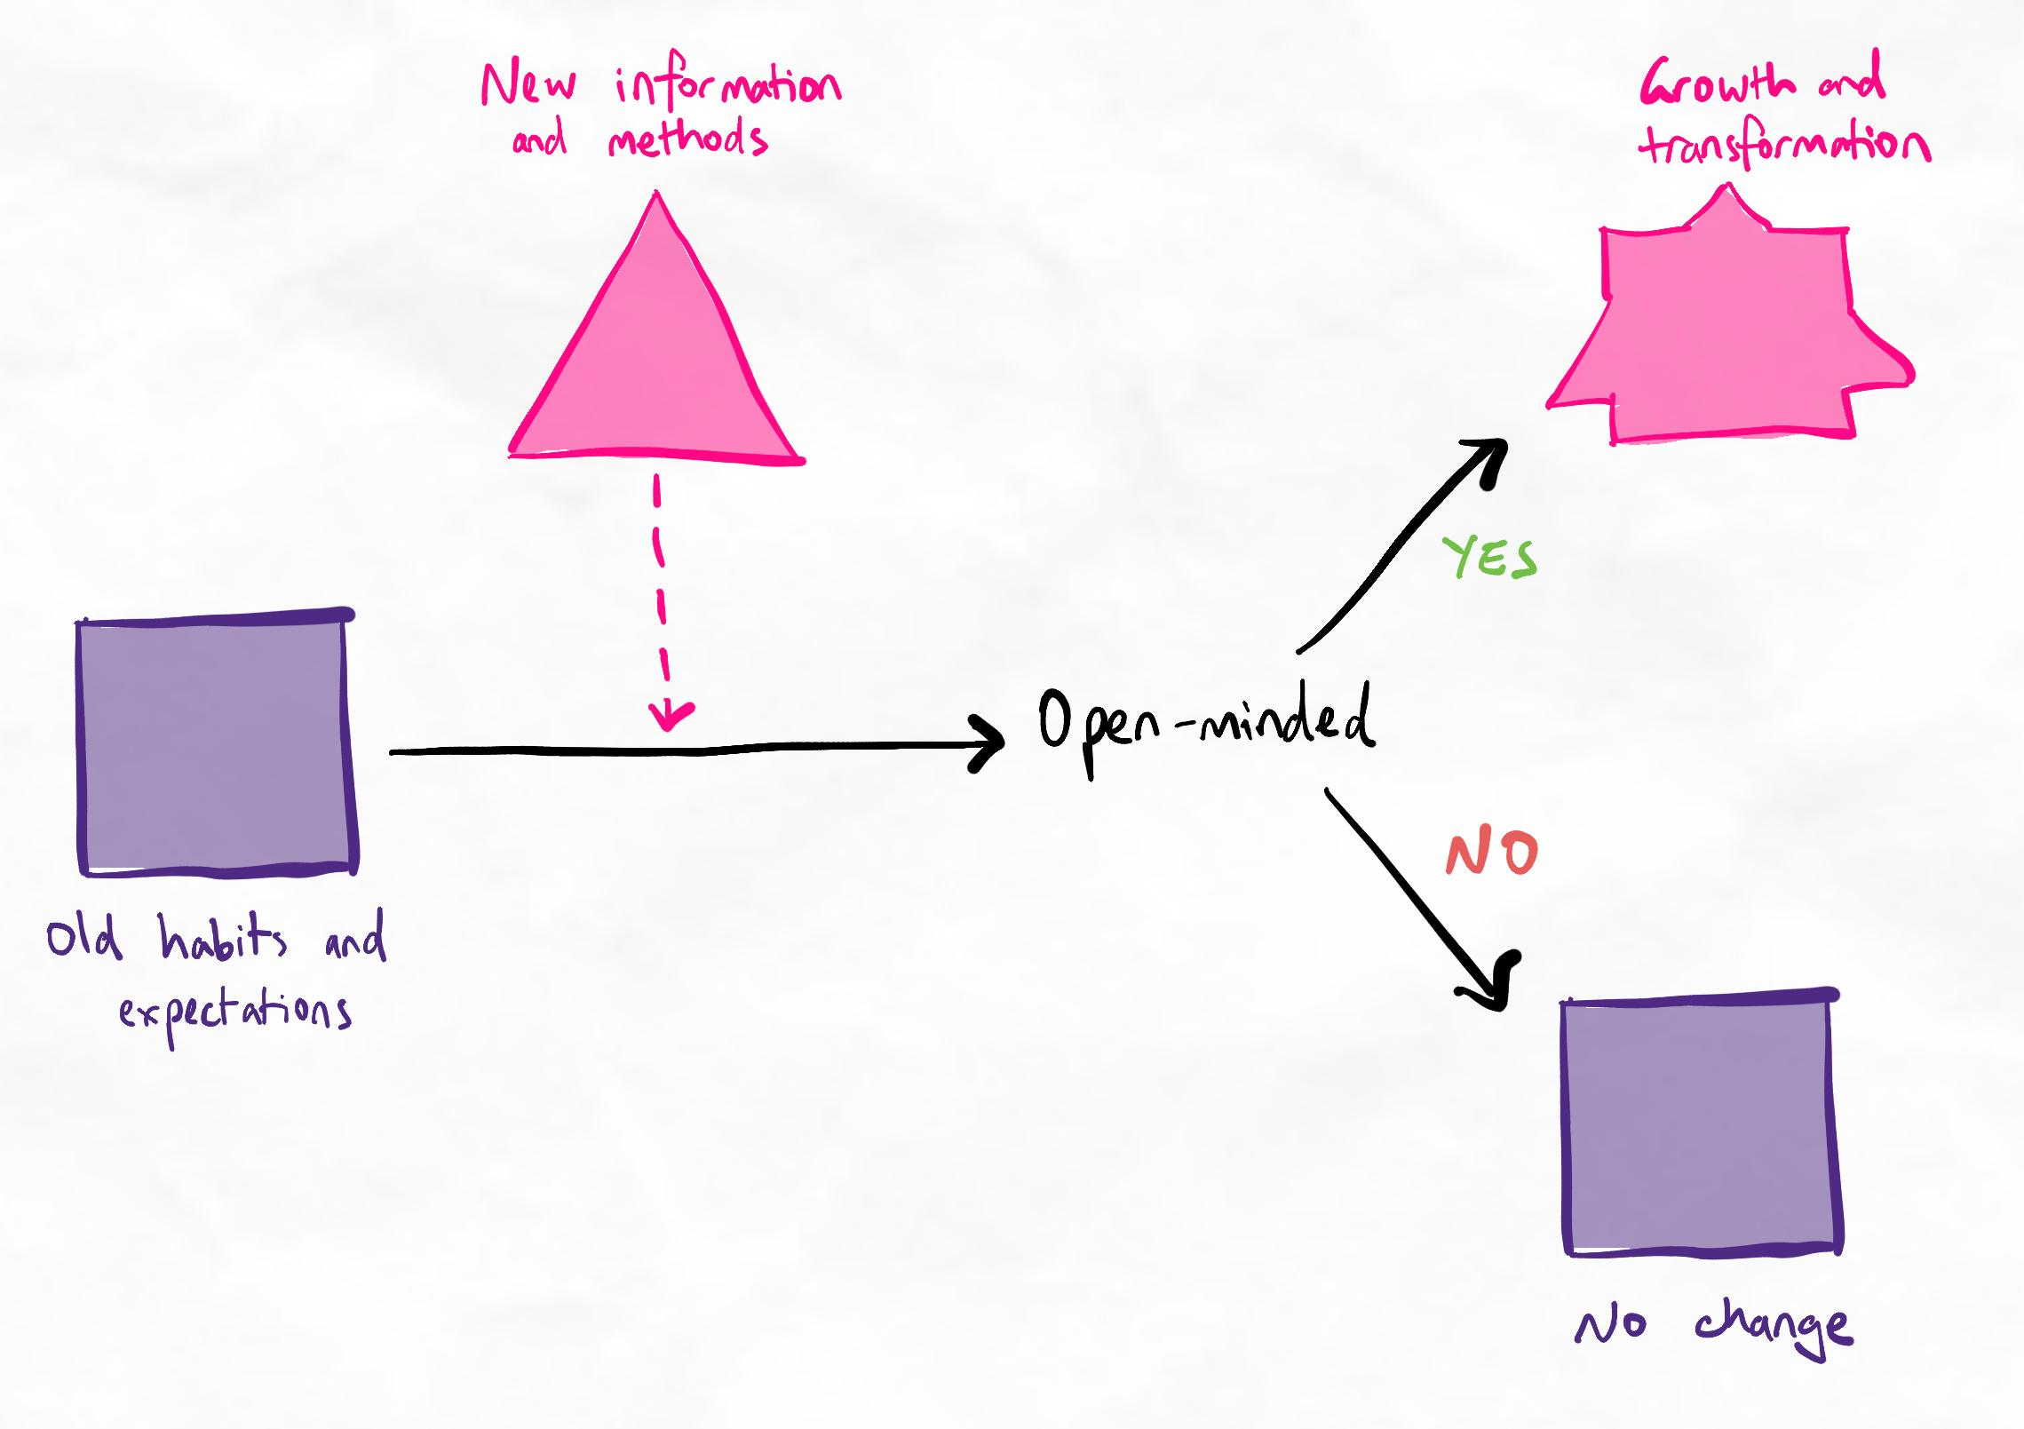Sometimes, the change we are looking for is not what we expect it to be.
Open-mindedness is a door that allows us to grow and transform, even if the change in methods and habits we need is not what we expect we need.
Accelerate unlearning
Tips for ensuring effective unlearning
- Observe how you react when new methods seem to contradict your expectations. Do you remain open or close off to the idea?
- Spot your hesitancies. Are there methods you feel reluctant to try because it goes against your existing system or habits? This could become problematic.
- Avoid 'tug of war' practice. This is when you revert to old habits or alter methods to be 'easier' when new methods become difficult or unfamiliar. This prevents our brain from properly retraining itself. Tug of war practice can be subtle!
- Avoid 'batman' style practice. This is when new methods are practised separately without replacing existing methods. Old habits by day, new methods by night! Like 'tug of war', this prevents retraining of habits.
8.Scheduling


In the sublessons below, we'll refresh on some of the basics of scheduling and time management.
Sublessons
- Scheduling mistakes
- Scheduling better – prioritising
- Scheduling tips

  - Scheduling mistakes
Common mistakes
How's your time management going so far?
The basics you learned in the High-Yield phase are often enough for most people. But if you're struggling with consistency, you might be running into these mistakes:
Not scheduling: If you’re the type of person who “wings it” and has no structure in their studying, it is time to make some plans.
Vague scheduling: This happens when you are not specific enough with your scheduling (e.g. allocating time for “Maths” or “English” but not specifying what you’re going to do).
Overambitious scheduling: If you can’t follow your schedule because it’s overpacked and unrealistic, you may become demoralised and stressed and give up.

ii.Scheduling better – prioritising
Tasks over time
Prioritising maximises the value of your time. Just 15 minutes spent prioritising can save you days. This is why task prioritisation is more important than time management.
Not all time is spent equal.
Time spent on something that gets you to your goals is more important than time spent on something less meaningful.
No matter how great your schedule is, it won’t help you reach your goals if it is not aligned with those goals. To achieve your goals as efficiently as possible, you must prioritise the content of your schedule.
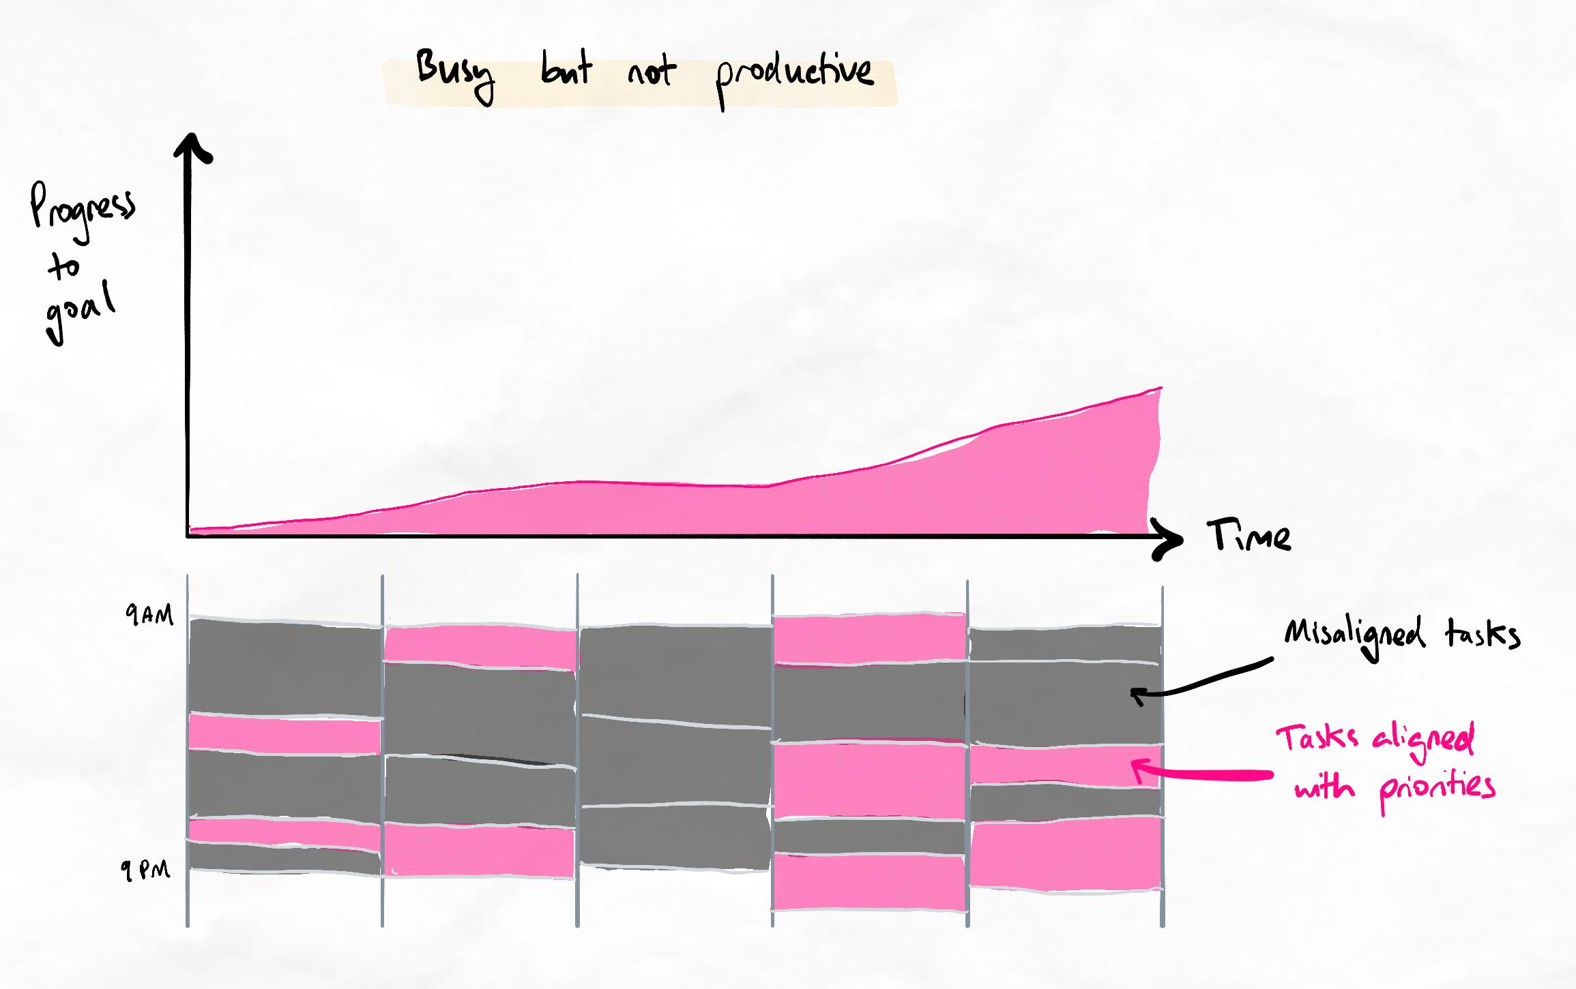When we have full schedules, but the tasks are not well-prioritised, we do not improve our position or progress towards our goal effectively.
Don't confuse being busy with being productive. Productive usage of time means that your time is spent on things that get you closer to your goals (whatever those goals are).
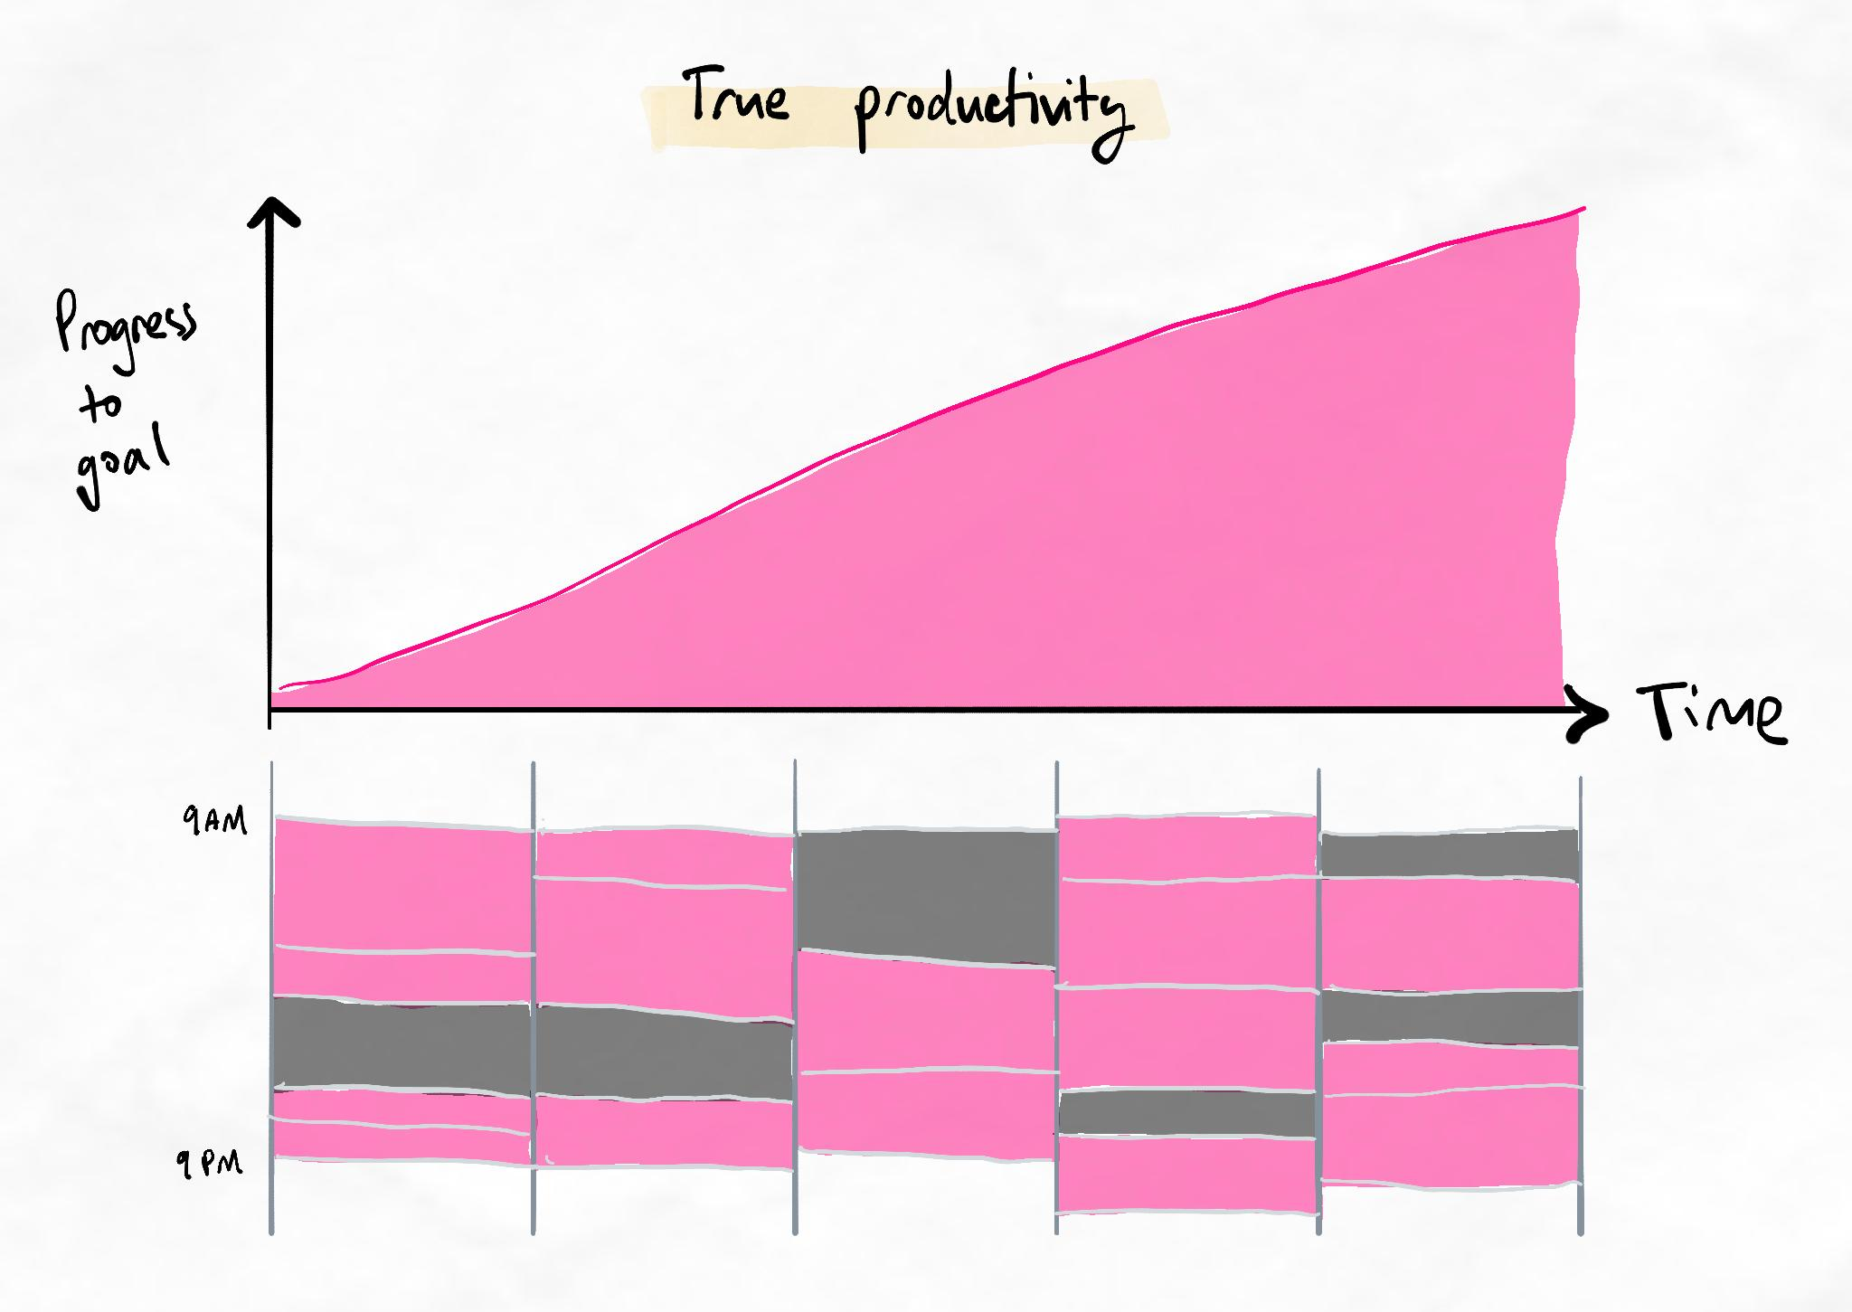When most of our tasks are prioritised, we make much faster progress towards our goal without being any busier!
A simple priority check
At the end of every day, identify the one or two highest priority items that put the future you in the best position. Remember that urgent doesn't always mean important!
Once you have identified these, block them into your schedule. All of your other tasks should be centred around these blocks.
Helpful questions for prioritising well
Ask yourself these questions to identify high priority items to block out in your schedule
- What are the one or two most important things for me to complete?
- What (if done) would provide me the best value or put me in the best position in the future?
- What skill, attribute, or resource do I need that would be life-changing (even if it isn't urgent right now)?
You may be interested in this YouTube video for a brief demonstration using the same principles.

iii. Scheduling tips
Scheduling guidelines
This lesson will show you how to schedule according to your priorities. You can go through this like a checklist.
Set your priorities first, then set your schedule.
You should transition from setting weekly priorities to setting daily priorities. Every night, make sure to set your schedule for the next day.
Guidelines
- Schedule your top two priority items first.
- Use either a diary or digital schedule. For most people, digital apps are more efficient and manageable, but if you have a low volume of tasks, pen-and-paper may be sufficient.
- Be very specific in your scheduling entries. To avoid procrastination, break down your study time into 30-minute blocks, and make sure to leave breaks and gaps.
- Overestimate the time required to complete each task by 25 to 50%.
- Ensure 15 minutes of buffer between each task.
- Have at least one hour of unscheduled time per day as emergency.
- Schedule time for reflecting and setting priorities at the end of every day.

9.Loss aversion
"Good enough"
After seeing all of the skills and strategies in this course, you may feel it’s too difficult or time-consuming to implement and practise them.
Often, learners have expressed that their current methods are “good enough”. However, many people have commented to us in our community, through emails, reviews, and in-person, that they regretted this months or years later.
The small pond
People often compare themselves with those immediately around them. They feel satisfied as long as they outperform the people they can see. However, this is misleading if you are having to compete against others outside of your immediate visibility.
Ask yourself: Am I comparing myself to others, or am I comparing myself to my standards?
Key principle
Always seek to set realistic and appropriate standards and use them for comparison. Comparing yourself to others to understand your performance is risky, unreliable, and unhealthy.
Short-term pain, long-term gain
What is “good enough” now may not be good enough for the future. People have a misconception that if things become more difficult, they can solve it by just trying harder. However, this often fails because everyone else also tries harder!
Ask yourself: Am I preparing myself for future challenges?
Key principle
Always seek to use and familiarise yourself with methods and approaches that will help you both in the short and long term. If your current method is heavily effort and motivation-dependent, this leaves very little room for error or improvement.
Loss aversion bias
Loss aversion is a phenomenon whereby people always prefer not to lose something they already have, even if it means forgoing an opportunity to gain something else. Because of loss aversion, you may tend to think your current process is “good enough” and hesitate to make changes.
Ask yourself: Am I investing in gaining skills and assets that will benefit me for life, or am I avoiding the opportunity to gain tomorrow out of fear of losing today?
Key principle
Become aware of when you make decisions out of fear and avoidance. This can indicate that your decisions are being made with too much emotional mind and not enough rational mind!

Further reading on loss aversion
Loss aversion is a phenomenon that has been shown repeatedly in multiple replicated studies. There is also some newer evidence that suggests that the effects of loss aversion can be subtle and unpredictable.

Risk management
Part of overcoming the “good enough” mentality is systematically sorting through our “risks”. Sometimes, the risks we perceive in a decision or action may not be the full scope of the risks.
Perceived risk | Hidden risk of this behaviour
Risk of time wasted compared to alternatives.  E.g. "I don't have the time to practice these techniques when there is so much already I'm behind on!" | Risk of continuing to fall behind as current methods caused us to fall behind in the first place.
Risk of investing time and effort into making unnecessary changes.  E.g. "I'll be ok with what I'm doing now. It's worked fine so far!" | Risk of losing out on long-term opportunities due to inadequate skills.  Risk of being unable to overcome future challenges if the difficulty increases.
Risk of learning new skills incorrectly or getting things wrong. | Risk of never learning new skills due to avoiding experimentation.

10. Final checkpoint – Technique Training
Checkpoint items
To move on, you must have around 80% competence with the skills taught so far. Use the list below to check whether you're ready!
Note: Lower levels of competence with even one of the items can be problematic during later stages where we build on these foundations.
Technique training checkpoint
- You use non-linear, processed notes. You are are becoming comfortable with non-linear mapping.
- You have a consistent, regular and high-quality Kolb’s cycle.
- Your inquiry step helps you to explore and identify relationships.
- You identify multiple relationships from a single concept, not just one or two.
- You compare relationships to find similarities and differences.
- You create groups based on these similarities and differences.
- Your mindmaps have a clear backbone of major ideas.
- You are seeing progress through marginal gains as a habit.
- Your spacing schedule is more refined and consistent.
- Your mastery of interleaving techniques is improving.
- You do systematic prioritisation and task management as part of your routine.
- You have reduced distractions and procrastination.
General competence
Technique(s) | Level of Competency
Traffic light system + non-linear note-taking | You can ask high-quality questions at a semi-habitual level. The answers to these questions allow you to chunk information and identify relationships between chunks and sub-chunks. You can express these chunks and relationships through processed notes.
Scheduling basics + Revision basics | You can create flexible schedules and consistently follow them. You can schedule regular revision following the revision guidelines.
Prestudy | You can schedule in regular prestudy. You can use the traffic light system and combine it with processed notes to create basic chunks and big relationships.
BEDS-M | You can improve your focus and reduce distractions by following the BEDS-M checklist to a semi-habitual level.
Unlocking the next stage
Ascent 1 is unlocked 14 days after Briefing is completed. If you've been practising the new theory and progressing at the recommended pace, it should be unlocked already by now!
If the next stage is still not unlocked, please use this time to practise your current method and gain deeper mastery.
Warning: In the Ascent stages, we have found that any weaknesses in fundamentals will be magnified. In some cases, it can take months to diagnose and repair problems caused by inaccurate fundamentals.
Recommended tasks
Add tasks to your focus list so you can practice the skills.
Dimensions
Technique Training
Complete a challenge week using all methods learned so far
For the next one week, use all of the methods you have learned so far around:
  - Prioritising
  - Time management
  - Pre-study
  - Note-taking and encoding with TLS
  - Interleaved retrieval
  - Focus and procrastination management
Complete at least three Kolb's cycles to increase your marginal competence with each technique and how the system works as a whole.
Table of contents
- Technique Training checkpoint quiz
- Progress Check

Technique Training checkpoint quiz
Spot the issues!
In the following quiz, we will show you some work submitted by real students. Each case has a common mistake for you to learn from. Sometimes, you will learn about certain mistakes for the first time from these checkpoint quizzes!
The impossible quiz
This quiz is designed for you to fail on your first attempt. This is because you will intentionally be tested on concepts that have never been explicitly taught to you.
Impossible quiz instructions
How to make the most out of these quizzes
- On your first attempt, try your best to get the questions correct by using logic and thinking about the principles you have learned. It is 'technically' possible to get each question right if you understand the principles very deeply!
- Review the learning notes at the end of the quiz and compare it with your own thought processes while you were answering them.
- Attempt the quiz again!

Question 1
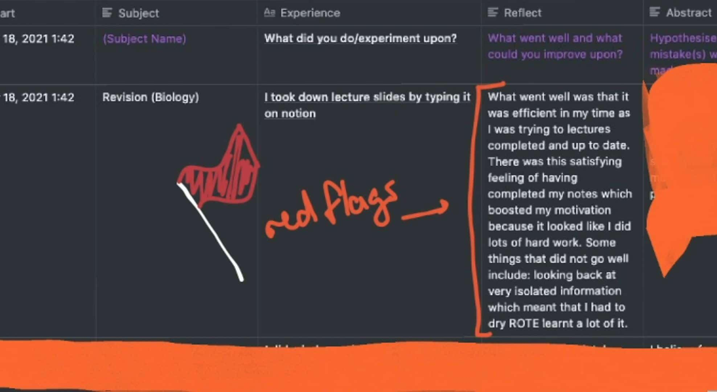
Regarding the work submitted by a student above, answer the questions below.
Which of these patterns are present in the area marked as containing “red flags”? Select all that apply.
Brief reflection
Solutions as progress
Studying over learning
Non-cyclical Kolb's
Insight-action mismatch

Ans: Brief reflection
Studying over learning

Question 2

Regarding the work submitted by a student above, answer the questions below.
Question 2.1
Studying over learning is:
Measuring success and effectiveness based on how much they are studying (hours, pages of content covered), instead of more meaningful metrics such as retention or depth/mastery achieved in the same time.
Focusing on executing a new technique as quickly as possible without considering accuracy of the technique.
A preference for easier learning techniques which do not require much cognitive load and effort.
A preference for more “secure” techniques such as linear notetaking over non-linear notetaking, which can take longer or feel less comfortable.

Ans: Measuring success and effectiveness based on how much they are studying (hours, pages of content covered), instead of more meaningful metrics such as retention or depth/mastery achieved in the same time.

Question 2.2
Studying over learning occurs because:
Time pressure makes it more appealing to revert to easier habits.
Learners are generally lazy and unmotivated to succeed.
Peer pressure makes learners competitive and want to appear the most impressive by studying the most hours.
Learners are unaware of the multiple factors that influence learning efficiency.

Ans: Learners are unaware of the multiple factors that influence learning efficiency.
Learning notes
99.99% Of Beginners Makes This Mistake
Studying over learning is when people do not understand how to correctly measure their learning efficiency. Traditionally, learners measure their learning efficiency based on simply content covered over a period of time. However, this is problematic because it drastically oversimplifies learning to the point where measuring efficiency in this way becomes harmful. The consequences of studying over learning are demotivation and frustration as the marginal gains of efficiency gain are not seen. We strongly recommend that you review our article on how to measure learning efficiency here.
The other mistake seen in this case is brief reflection. This is simply when there is not much information given in the reflection part of Kolb’s. This may occur due to inadequate self-awareness (which must be developed over time) or a lack of effort (which can be solved immediately). A common sign of brief reflection is when only single sentence answers or a couple bullet points are given as the answer to each prompting question of Kolb’s reflection.

Question 3
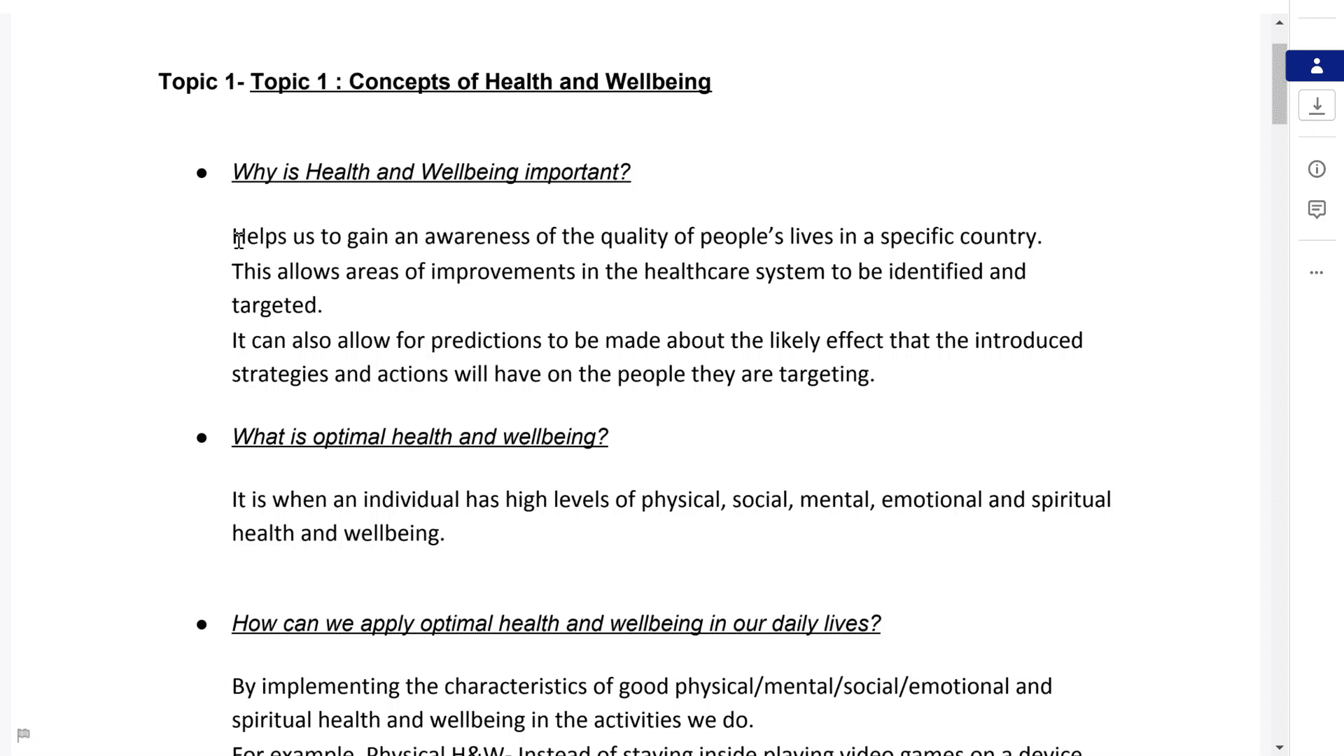
Regarding the work submitted by a student above, answer the questions below.
Which of these patterns are present? Select all that apply.
Prechunking
Simple question and answer
Lower order inquiry
Cognitive load intolerance
Resource overload

Ans: Simple question and answer
Lower order inquiry

Question 4

Regarding the work submitted by a student above, answer the questions below.
Question 4.1
Simple question and answer is:
Questions are lower-order in nature.
When questions are answered with a single answer rather than considering multiple possibilities and exploring relationships.
When questions are typed out linearly and in a list.
When questions are answered using just one resource.

Ans: When questions are answered with a single answer rather than considering multiple possibilities and exploring relationships.

Question 4.2
Simple question and answer occurs because:
Learners are unable to formulate higher order questions.
Learners are presented with too many resources which creates cognitive overload.
Learners treat the questions in inquiry-based learning as a direct question to be answered, rather than a springboard and direction to explore relationships and patterns.
There is only one possible answer to the question.

Ans: Learners treat the questions in inquiry-based learning as a direct question to be answered, rather than a springboard and direction to explore relationships and patterns.
Learning notes
A One Way Traffic Light
Simple question and answer is a common mistake for those first engaging in self-directed inquiry-based learning. The purpose of questioning is to help direct the brain to identify relationships and similarities. These similarities are the foundation for creating groups and chunks. The relationships also help to create a flow of interconnected chunks and concepts. In simple question and answer, learners do not explore multiple possible answers and instead just answer each question as directly as possible, as if it were an exam. This bypasses the discovery of relationships, which makes chunking and relational learning very difficult.
The other mistake visible is lower-order inquiry. This is when the questions only have one possible answer to begin with. These questions are often fact-based and start with “what”. These questions are not useful for forming networks and enhancing memory or depth of understanding. Often, lower-order questions can make learners feel overwhelmed while also being ineffective for learning. For more information, we recommend you review the lessons on the Traffic Light System for guidelines on how to ask higher-order questions.

Question 5
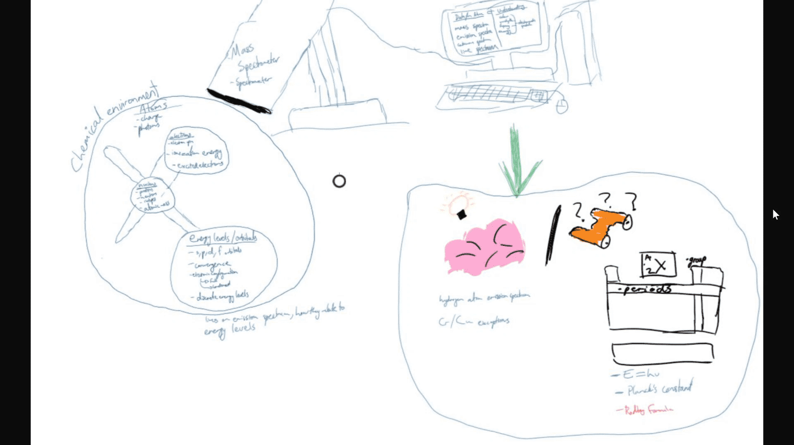
Regarding the work submitted by a student above, answer the questions below.
Which of these patterns are present? Select all that apply.
No backbone
Waterfalling
Lower order inquiry
Insufficient chunking
Spiderwebbing

Ans: No backbone

Question 6

Regarding the work submitted by a student above, answer the questions below.
Question 6.1
No backbone is:
When there are no visuals drawn for the main ideas.
When there are no main ideas identified or the relationship between them is unclear.
When there are only 3 main ideas.
When there are too many relationships between the concepts.

Ans: When there are no main ideas identified or the relationship between them is unclear.

Question 6.2
No backbone can occur because (select all that apply):
The content being studied is too overwhelming.
The learner does not deliberately attempt to clearly establish the most important chunks and the relationships/flow between them.
The learner is too focused on the details and ignores the overarching ideas or big picture.
The learner does a prestudy which is so comprehensive that there is no need for identifying the main ideas anymore.
Ans: The learner does not deliberately attempt to clearly establish the most important chunks and the relationships/flow between them.
The learner is too focused on the details and ignores the overarching ideas or big picture.
Learning notes
Beginner Prestudying - Room For Room
The no backbone mistake is a common mistake that can often be fixed easily and offers a large benefit for memory and understanding. No backbone refers to the lack of a clearly identified set of main ideas or chunks and the lack of a clear flow between these main ideas or chunks. The result can be a map that has relationships (sometimes many more than in the example case here), but it is unclear how it connects together or to gain a sense of the big picture. It can also occur when there is too much focus on the details at an early stage of the learning. Make sure to keep an eye on the big picture and constantly look for the clearest and simplest way to express these ideas.

Question 7
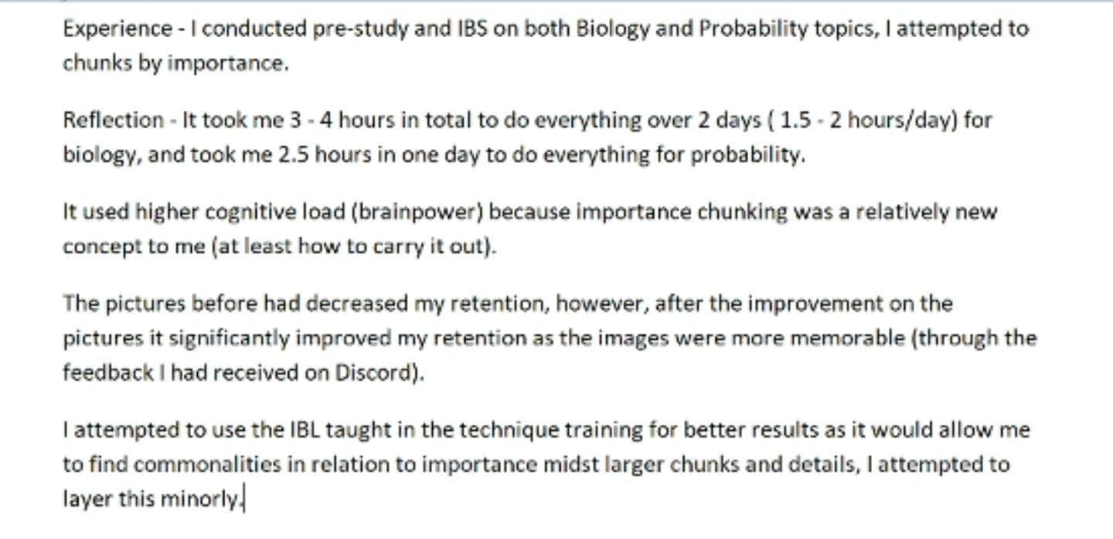
Regarding the work submitted by a student above, answer the questions below.
This student has demonstrated several qualities that indicate they are on the right track for success. Which of the following traits are present? Select all that apply.
Seeking feedback and acting on the feedback.
Trying to understand the technique as much as possible before giving it a go.
Recognising signs of effective learning and persisting, even when it is difficult.
Choosing only the most relevant techniques and skills to learn.
Focusing on their learning processes, rather than the act of studying.
Measuring their learning success by the marks they've achieved.

Ans: eeking feedback and acting on the feedback.
Recognising signs of effective learning and persisting, even when it is difficult.
Focusing on their learning processes, rather than the act of studying.

Question 8

Regarding the work submitted by a student above, answer the questions below.
Question 8.1
Seeking feedback helps to prevent the “echo chamber” mistake. Echo chamber is:
Practising techniques on your own while rarely seeking feedback.
Teaching to an empty room as part of your SIR.
A desire to gain ultimate clarity on a technique before trying it out.
Choosing to repeat a selected few SIR techniques.

Ans: Practising techniques on your own while rarely seeking feedback.

Question 8.2
Echo chamber leads to:
Errors and deviations in technique due to a lack of calibration.
Missing gaps in knowledge during a SIR session because there is no audience to question you.
A lack of practice, due to excessive effort spent on seeking information.
A high level of knowledge, but a lack of execution.
Ans: Errors and deviations in technique due to a lack of calibration.
Learning notes
Finding Flags - Technique Training

